Evan Richter

Homework 4

1. The maximum value of an color component is 255 because red green and blue are all 8-bits so the highest possible range is 2^8 or 255.

2.

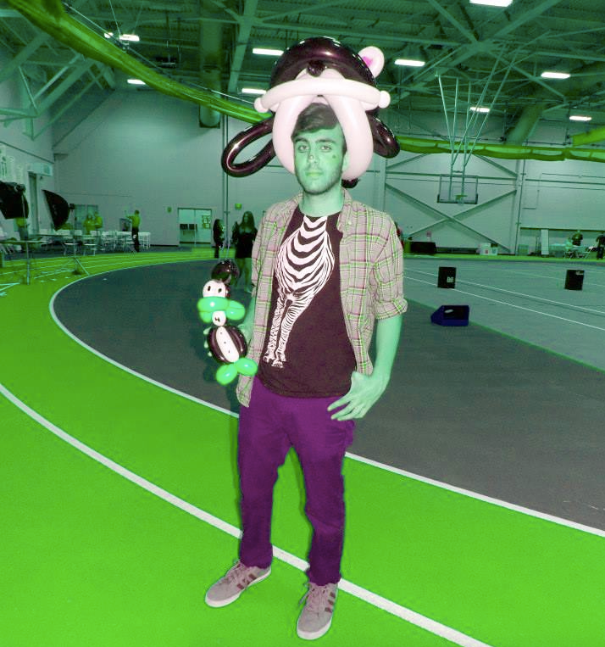

3.

4. it switches red to green and vice versa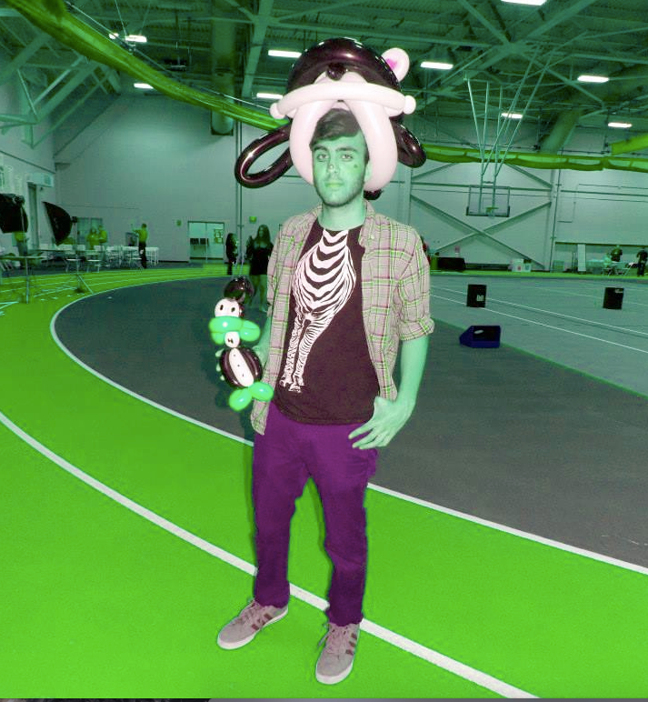

5.def colorSwap(pict):

for p in getPixels(pict):

red = getRed(p)

green = getGreen (p)

blue = getBlue (p)

color = makeColor(red,red,red)

setColor(p,color)